# Department of Software Engineering

**CS 474: Computer Vision**

**Class: BESE-7**

**Lab 2: Harris Corner Detector**

**Date: 27th Jan 2020**

**Time: 10:00 am-1:00 pm**

**Instructor: Dr. Muhammad Moazam Fraz**

**Lab Engineer: Ms Anum Asif**

**Course Learning Outcomes (CLOs)**

|  |  |  |  |
| --- | --- | --- | --- |
| Upon completion of the course, students should demonstrate the ability to: | | **PLO Mapping\*\*** | **BT Level\*** |
| CLO 1 | Understand computer vision algorithms and tools and techniques. | PLO 1 | C2 |
| CLO 2 | Develop solutions for image/video understanding and recognition. | PLO 3 | C3 |
| CLO 3 | Use modern tools to solve practical problems. | PLO 5 | C5 |

* BT= Bloom’s Taxonomy, C=Cognitive domain, P=Psychomotor domain, A= Affective domain

* *Knowledge(C-1), Comprehension(C-2), Application(C-3), Analysis(C-4), Synthesis(C-5), Evaluation(C-6)*

*\*\* PLOs are published on department website*

**Lab 2: Harris Corner Detection**

**Learning Outcome**

CLO 1: Understand computer vision algorithms and tools and techniques.

**Introduction**

Corner Detection is an essential step in many computer vision algorithms. Within this lab we implement Harris Corner Detection.

**Objectives**

In this lab you will understand the concepts behind Harris Corner Detection.

**Tools/Software Requirement**

Python / MATLAB

**Description**

In computer vision, usually we need to find matching points between different frames of an environment. Why? If we know how two images relate to each other, we can use *both* images to extract information of them. When we say **matching points** we are referring, in a general sense, to *characteristics* in the scene that we can recognize easily. We call these characteristics **features**. **So, what characteristics should a feature have?** It must be *uniquely recognizable.*

**Types of Local Image Features**

To mention a few:

* Edges
* **Corners** (also known as interest points)
* Blobs (also known as regions of interest )

In this lab we will study the corner features, specifically.

Because, since it is the intersection of two edges, it represents a point in which the directions of these two edges change. Hence, the gradient of the image (in both directions) have a high variation, which can be used to detect it.

The algorithm for Harris Corner Detection is given below.

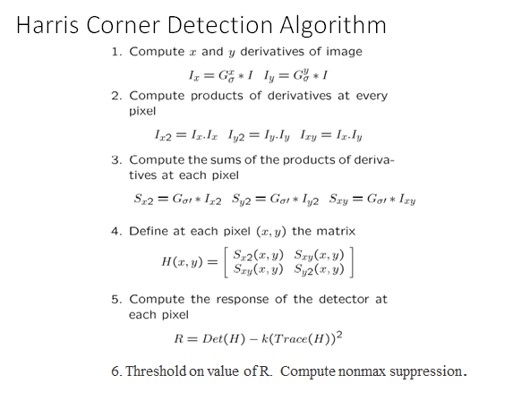

**Lab Tasks**

**Steps:**

1. Load the image provided. Compute horizontal and vertical derivatives of image.
2. Compute three images as shown in algorithm step 2 of algorithm.
3. Compute the partial derivatives (gradients) of images as mentioned in step 3.
4. After step4 in algorithm, compute the response of detector at each pixel as shown in step5.
5. Find local maxima above some threshold as detected corner. You can experimentally choose appropriate value of this threshold

**Deliverable**

* Jupyter Notebook submitted on LMS